Task 1: To Detect Variable References, Expand Values, Handle Undefined Variables, Update Tokens, Support Nested Variables, Test Expansion Logic.
Code:
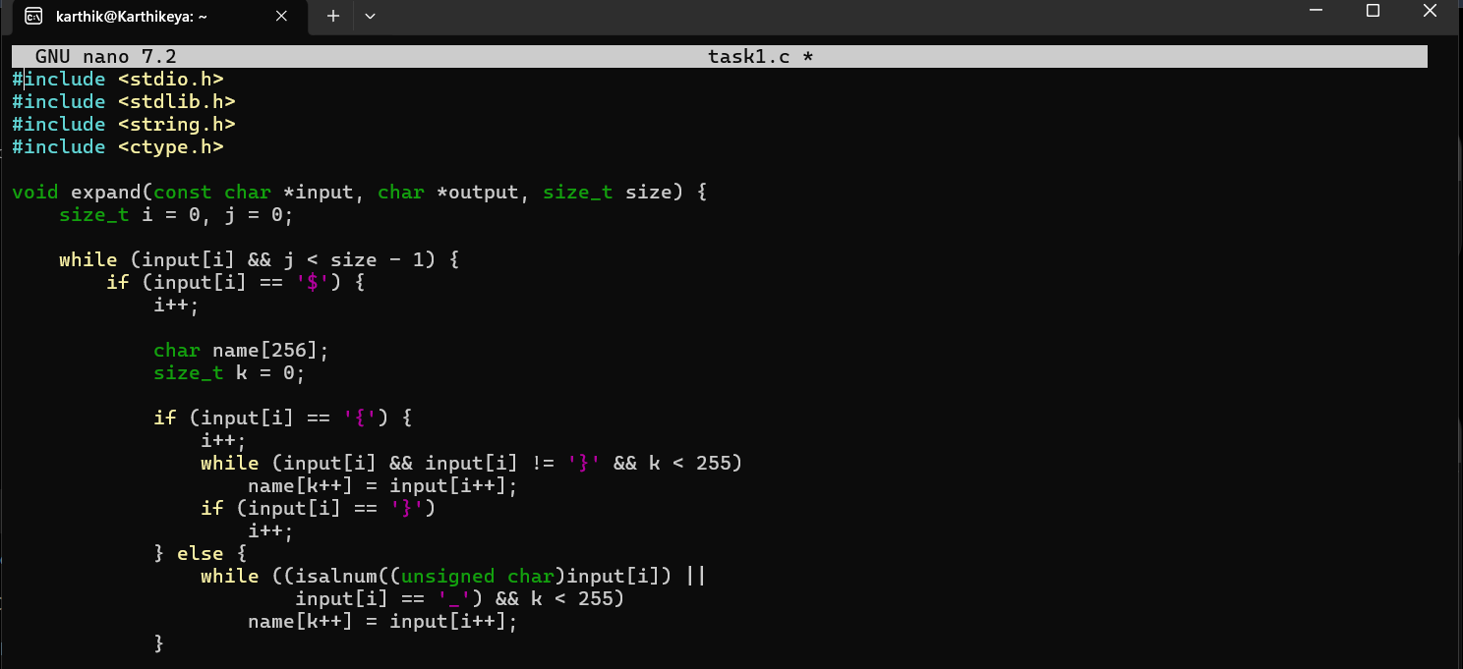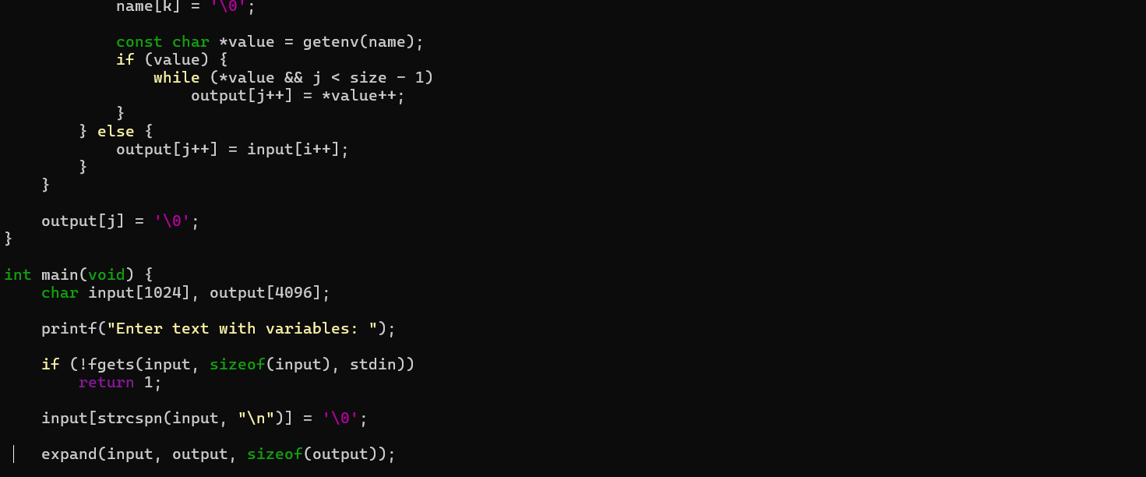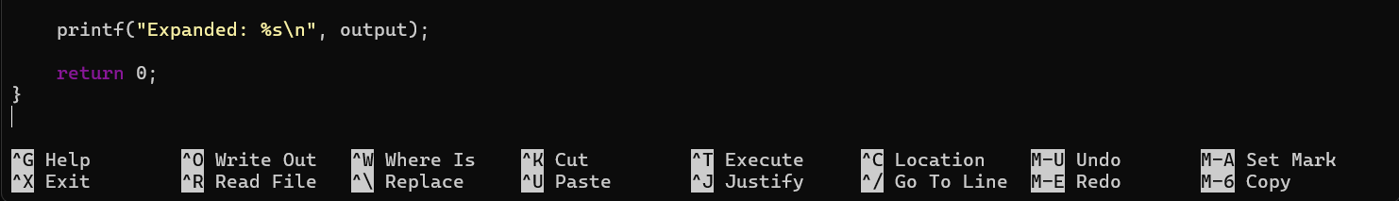

Output:
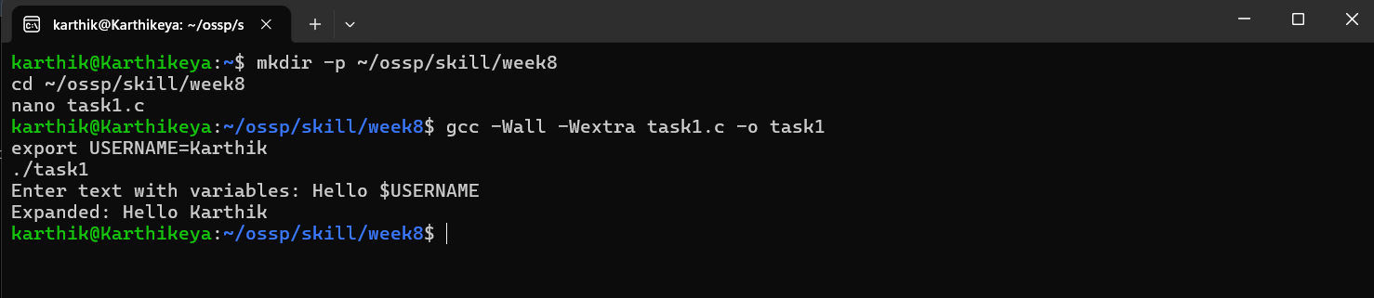
Task 2: To Identify Built-ins, Create Dispatch Table, Execute In-Process Commands, Handle Invalid Commands, Maintain State, Test Dispatch Logic.
Code:
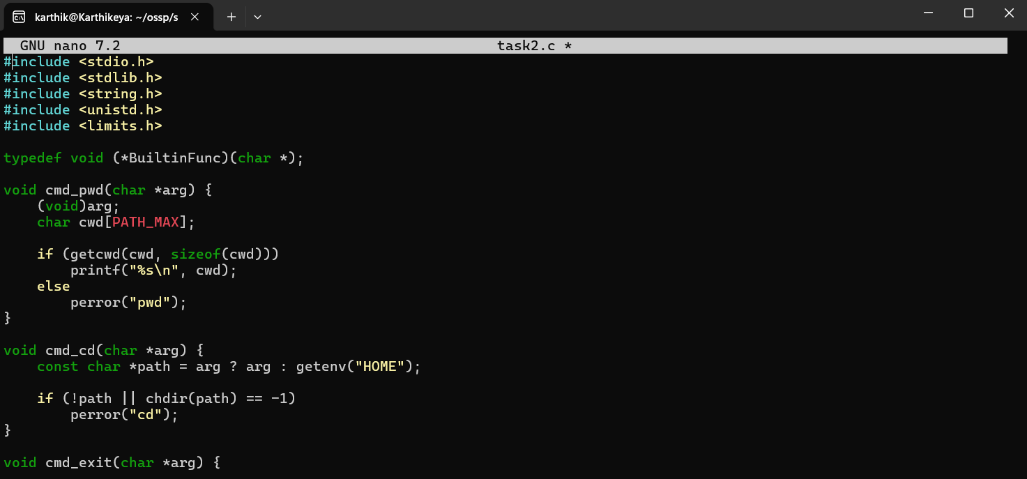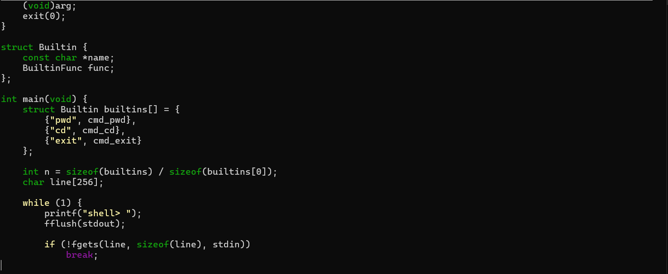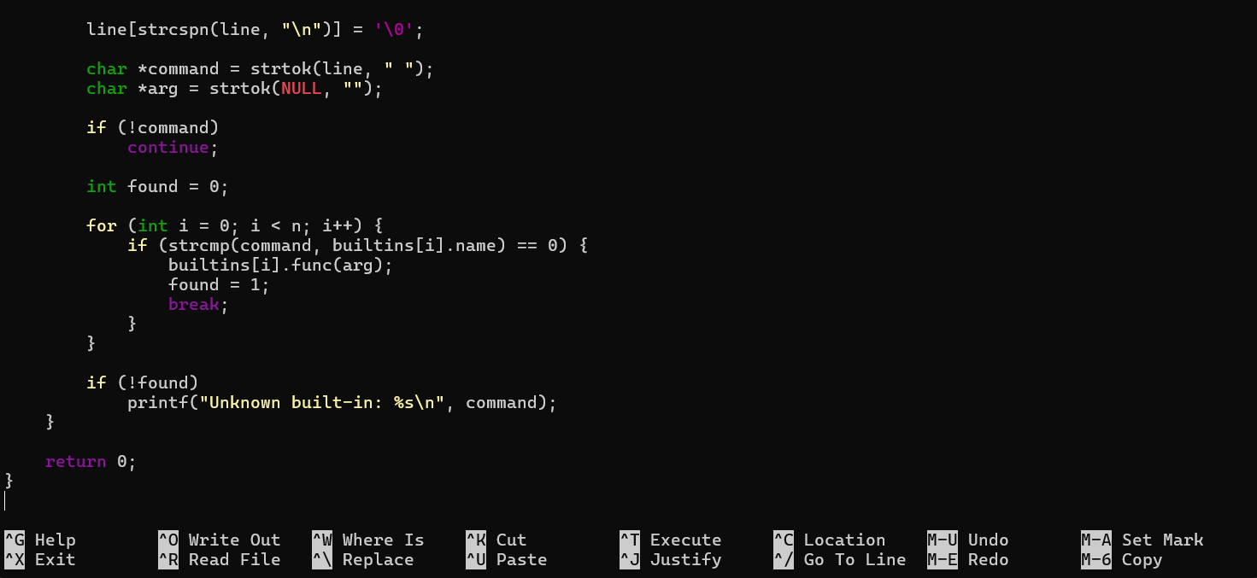
Output:
